RESOLUTION NO.__________

RE: CERTIFICATE OF APPROPRIATENESS UNDER THE
PROVISIONS OF THE ACT OF THE PENNSYLVANIA
LEGISLATURE 1961, JUNE 13, P.L. 282 (53
SECTION 8004) AND BETHLEHEM ORDINANCE NO.
3952 AS AMENDED.

WHEREAS, it is proposed to improve facades of two dwellings at 519–521 Wyandotte Street.

NOW, THEREFORE, BE IT RESOLVED by the Council of the City of Bethlehem that a Certificate of Appropriateness is hereby granted for the work.

Sponsored by: (s)

(s)

ADOPTED BY COUNCIL THIS DAY OF

(s)
President of Council

ATTEST:

(s)
City Clerk

HISTORIC CONSERVATION COMMISSION

CASE # 597– It is proposed to improve facades of two dwellings at 519–521 Wyandotte Street
OWNER/APPLICANT: (519) Michael Young:(521) Lehigh Valley Community Land Trust/ Community Action Committee of the Lehigh Valley

The Commission upon motion by Mr. Lader seconded by Mr. Traupman adopted the proposal that City Council issue a Certificate of Appropriateness for the proposed work described herein:
- The proposal to improve facades of two dwellings at 519–521 Wyandotte Street was represented by Lynne Holden and Mike Handzo.
- The façade renovations will be undertaken as proposed with the following modifications or clarifications:
  - The front doors will have 3/4 lights or 1/2 lights with lower panels.
  - The new front porch railings will have 2” (actual) square balusters, and new porch posts will be 6” in diameter.
  - The brick facades will be cleaned using a low pressure power wash. (400 psi)
  - The slate roof will be repaired in kind or shingled with GAF Slateline shingles in the Antique Slate color if repair is not feasible.
  - The new front steps will be concrete to match the neighboring house; A new traditional forged steel handrail with shaped top rail and lambs tongue detail at the top and bottom and square posts.
  - All wood will be repaired rather than replaced where ever possible. Epoxy consolidants and fillers should be used to repair wood as much as possible.

- The motion to approve the proposal was unanimously approved.

CU: cu
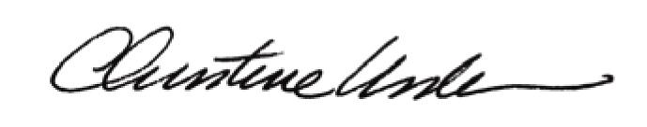

By:

Date of Meeting: September 19, 2016 Title: Historic Officer

